***Lab Manual 7, Lab Tasks – 1,2 and 3***

Fundamentals of programming

ME-15

Written by:

Faizan Ahmad

476602

Section: A

***Task 1:***

*Take 10 integer inputs from user and store them in an array and print them on screen.*

Code:

#include<iostream>

using namespace std;

int main() {

int a[10]; // integer array is declared since we are only dealing with integers

cout<<"Enter 10 numbers:"<<endl; // this is a prompt that asks the user for 10 integer inputs

for ( int i=0; i<10; i++ ) { // this for loop is used to cycle through each space in the array so that it may be filled with user inputs

cin>>a[i];

}

for ( int i=0; i<10; i++ ) { // this loop prints each integer in the array from space 0 to 9 (total 10)

cout<<a[i]<<" "; // space is printed between each number so that its easier to distinguish between numbers

}

return 0;

}

Screenshot of execute:

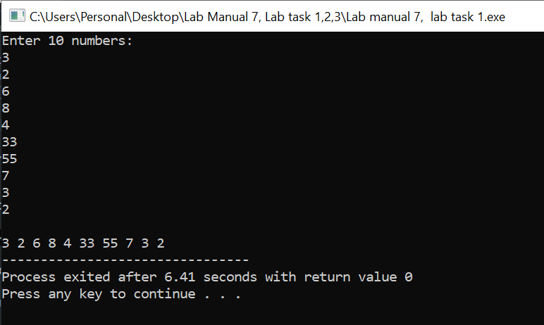

***Task 2:***

*Write a program to find the sum and product of all elements of an array with 5 integer elements.*

Code:

#include<iostream>

using namespace std;

int main() {

int a[5], sum = 0, product = 1; // integer array is declared since we are only dealing with integers

cout<<"Enter 5 numbers:"<<endl; // this is a prompt that asks the user for 10 integer inputs

for ( int i=0; i<5; i++ ) { // this for loop is used to cycle through each space in the array so that it may be filled with user inputs

cin>>a[i];

}

for ( int i=0; i<5; i++ ) {

sum = a[i] + sum;

product = product * a[i];

}

cout<<"The sum of the numbers inputed is: "<<sum<<endl;

cout<<"The product of the numbers inputed is: "<<product<<endl;

return 0;

}

Screenshot of execute:

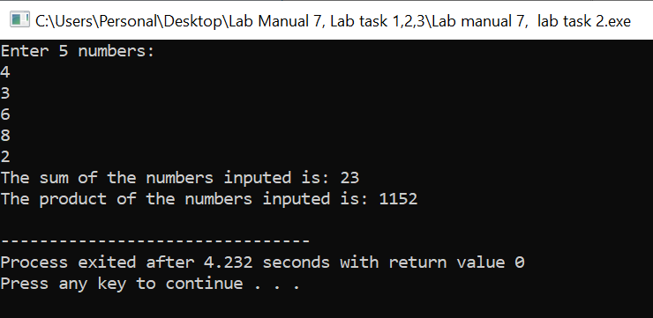

***Task 3:***

*Print diamond pattern using a single array.*

Code:

#include<iostream>

using namespace std;

int main() {

int n, half; // integer n represent the number of rows

// integer half represents the half of n, since its declared integer it will always be a number less then the actual half

// if n = 5 , n/2 = 2.5, half = 2

// this is strategic, since in a array the elements are labelled starting from zero, so the half of an array with n elements

// is (0,1,2,3,4) 2 hence half = 2

cout<<"Enter the number of rows of your diamond"<<endl; // prompt asking for number of rows

cin>>n; // read number of rows

char a[n]; // declaring a character array

half = n/2; // determining half

for ( int i = 0; i<n; i++ ) { // this loop replaces all the elements of the array with ' ' (spaces)

a[i] = ' ';

}

for ( int i = 0; i<= half; i++ ) { // this loop prints each row

a[half] = '*'; // in a diamond the middle element is always a '*' hence we replace the middle element with a '*'

a[half - i] = '*'; // replace the element on the left with a *, initial value of i is zero so the first row prints only with a * in the centre

a[half + i] = '*'; // replace the element on the right with a *

for ( int j = 0; j<n; j++ ) { // this row prints each column

cout<<a[j];

}

cout<<endl; // end line is used to move on to the next row

}

for ( int i = half; i >= 1; i-- ) { // this loop prints the rows below the middle row

// hence, we start from half and move backwords to 0, reverse the upper process

a[half - i] = ' '; // replace the * with ' ' from the edges inwards ( both from left and right hand side

a[half + i] = ' ';

for ( int j = 0; j<n; j++) { // print each column

cout<<a[j];

}

cout<<endl; // endl used to move onto the next row

}

return 0;

}

Screenshot of execute:

